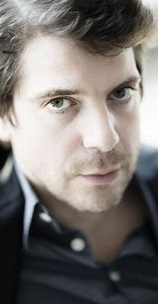

**Ramsey Nasr**

A Dutch poet, writer, essayist, actor, director, librettist and translator. He grew up in Rotterdam as the son of a Palestinian father and Dutch mother. He was the second city poet of Antwerp (2005) and was Poet Laureate of the Netherlands from January 2009 to January 2013.

Nasr often broaches social issues in his work. At the request of the association 'Recht-op', an association where the poor speak out, Nasr came into contact with many underprivileged people in Antwerp as city poet. Originally, the intention was to write a poem in support of a dossier on maintenance money. Since this was a very limited subject for a poem, Nasr suggested opening up the theme to underprivileged people in general and making it an official city poem.

The OCMW (the social service) offered - even before the poem was written - an outside wall on Mechelseplein in Antwerp.

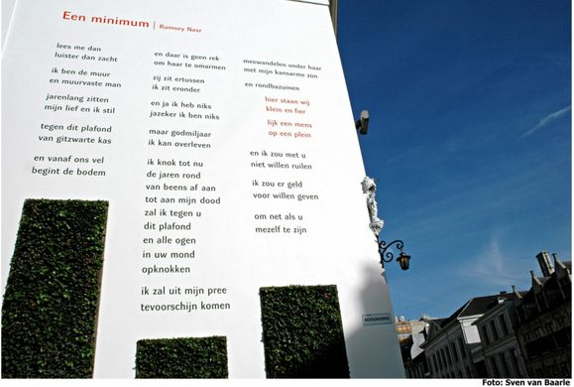

**een minimum a minimum**

*lees me dan* then read me

*luister dan zacht* then listen softly

*ik ben de muur* I am the wall

*en muurvaste man* and wall-solid man

*jarenlang zitten* for years

*mijn lief en ik stil* my love and I sit silent

*tegen dit plafond* against this ceiling

*van gitzwarte kas* of pitch-black paradise flower

*en vanaf ons vel* and from our skin

*begint de bodem* the soil begins

*en daar is geen rek* and there is no stretch there

*om haar te omarmen* to embrace her

*zij zit ertussen* she is in between

*ik zit eronder* I'm underneath

*en ja ik heb niks* and yes I have nothing

*jazeker ik ben niks* yes I am nothing

*maar godmiljaar* but goddamn

*ik kan overleven* I can survive

*ik knok tot nu* I fight till now

*de jaren rond* over the years

*van beens af aan* from the bone

*tot aan mijn dood* till I die

*zal ik tegen u* I'll fight you

*dit plafond* this ceiling

*en alle ogen* and all eyes

*in uw mond* in your mouth

*opknokken* I'll fight you

*ik zal uit mijn pree* from my wage

*tevoorschijn komen* I will emerge

*meewandelen onder haar* walk among her

*met mijn kansarme zon* with my underprivileged sun

*en rondbazuinen* and spread the word

*hier staan wij* here we stand

*klein en fier* small and proud

*lijk een mens* like a human being

*op een plein* on a square

*en ik zou met u niet willen ruilen* and I wouldn't want to change with you

*ik zou er geld voor willen geven* I would give money

*om net als u* to be, just like you,

*mezelf te zijn* myself

**WORKSHOP “A MINIMUM”**

Every era has its conflicts. From visiting the first room of the Red Star Line Museum, we learnt that people have always been on the move from the very first steps man took in Africa to the present day. Some on the run, others in search of food,... During the time of Jakob Fugger, some people also wanted or needed to move. In his time, there were religious wars and people tried to flee because they wanted to be able to practice their faith freely. At the end of the 19th century, a lot of Jews fled Eastern Europe as a result of the pogroms, but home emigrants also left after crop failures...

You see: there are a lot of different reasons, why someone flees, and why someone feels at home somewhere.

Therefore, in a first phase, we ask you to think on your own about these questions: (10 minutes)

* What makes you feel at home?
* What makes you stop feeling at home somewhere?
* Why would you leave that place?
* What do you need to feel at home elsewhere?
* What makes you (not) feel good in life?
* What gives you strength and energy?
* What do you find important in your life, in your dealings with others, ... ?

Several groups can now exchange with each other. Ideally, you should try to mix the groups so that there are different perspectives. It is important that they summarise what they have in common and where they differ. (20 minutes)

Then, for inspiration, we read "a minimum" by Ramsey Nasr. In doing so, we ask ourselves this question: what position does Ramsey Nasr take on poverty and surviving? (10 minutes)

We will now open up this theme and not limit it to poverty. Each group will now be tasked with using a mind map to collect the key points they want to use in a poem of their own to be written around the minimum you need to be able to come home / feel somewhere at home. (40 minutes)

Each group is tasked with creatively shaping this self-written poem and recording it on video. (20 minutes). The results you can see on our website.